Griggstown Lock Rapper Sword Team
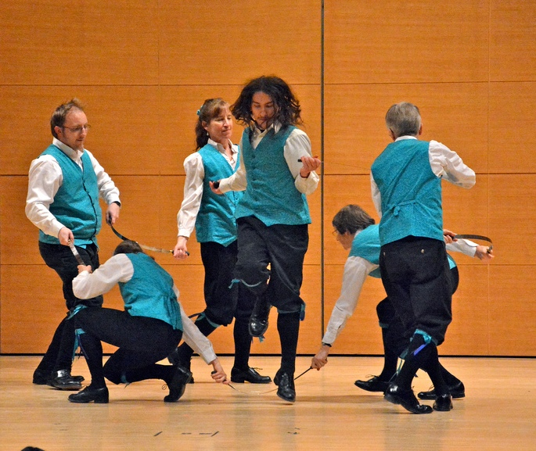
Griggstown Lock performs English rapper sword dances. Rapper dancing comes from Northumbria where it developed in the coal mining villages in the early 1800s. The dancers do a shuffle step to fast jig-time music played by a fiddler. Rapper dances are usually done with five dancers, but sometimes more, joined by short flexible ‘swords’ with a handle on each end. The team weaves intricate figures in which the dancers and the swords get tangled and untangled with occasional arrangement into a ‘lock’ in a star shape.
Jane McCarty and Michael Bell started Griggstown Lock Rapper Sword team in 1989 and the group performed at their wedding. The team which dances primarily in the Princeton, NJ area, takes its name from the lock, of a different kind, on the Delaware & Raritan Canal at Griggstown, NJ.
Griggstown Lock has choreographed many of its own dances and developed some new rapper dance figures including its unique double-sphere lock.
The team has performed at community events, street festivals, retirement communities, the Philadelphia Art Museum, the Hunterdon Art Museum, the Princeton University Art Museum, Historic Speedwell in Morristown, NJ and at the annual New England Folk Festival in Massachusetts. Along with many other sword dance teams, Griggstown Lock has danced in New York City in the Half Moon Sword Ale (see a video at https://www.youtube.com/watch?v=pvjObw8sp30&list=PL2P6o7enFAaL2k7V56mGHUTzqL49rQari&index=11).
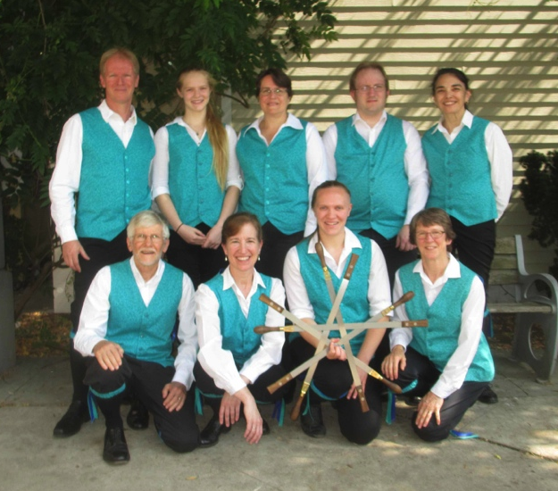
If you’re interested in seeing Griggstown Lock dance, having them perform at an event, or in dancing with the team, contact Jane or Michael at jdmgb@verizon.net or 732-297-6281. We practice on Monday nights just north of Princeton.

